IN605 Databases 2

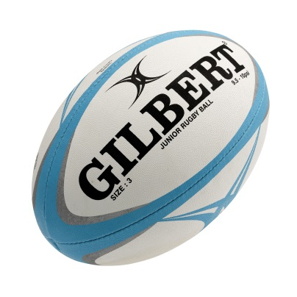

Data Model Assignment

Prepared for
Krissi Wood & Tom Clark

Prepared by
Adam Charlton

Otago Polytechnic
8 May 2013
Main Objective

The main objective of this database is to handle the registration of new and existing players. The database will store the input of all players & their caregivers, staff, gear, administration and game records.
Some of the main aspects that is required for this database:
The database is designed to keep a record of player details and team assignments, registration forms, staff assigned to teams, track the ground keys, gear/uniforms, gear bags and contents. The gear may include coach track suits, team uniforms, and a gear bag that holds several items such as a first aid kit, training cones, bibs and balls. Keys for the grounds will be recorded, along with a list of restricted persons who are allowed access to them.
The player’s age and weight are tracked in the database. This information is important because the divisions are based on age and weight, which is a requirement for team selection. The shop roster will also be recorded in the database. This will allocate a team to man the shop, allocation is based on which of the teams are having a home game. It is then up to the team to assign a person to the shop, which is entered into the database.
The database will have the ability to link all the players to their respective caregivers. This will minimize duplicate communications/newsletters being sent to caregivers who have more than one player in a team. It will also store whether the caregiver would like to receive the newsletter or not.
Team scores and season results will also be stored in the database. It will track awards such as the most valuable player and most improved player at the end of the season, and also the player of the day from each game.
The tracking of the store inventory is far too complex, therefore not in scope of this database. This function could be implemented separately then linked to this database at a later date.
The information that the user will be able to obtain from the Database once it is finished is the writing of the weekly newsletter, mail merges, games information to be published to the website and the ability to generate reports for the end of season and staffing purposes.

Use Cases

Player Registration
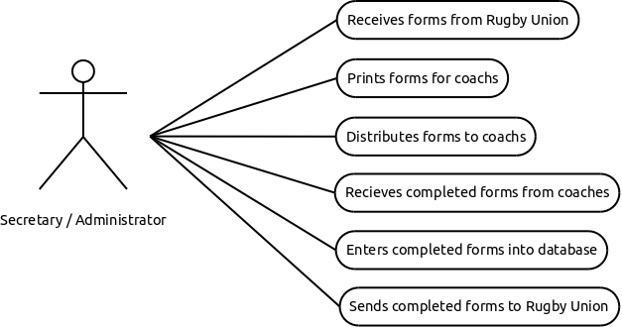

Send Information
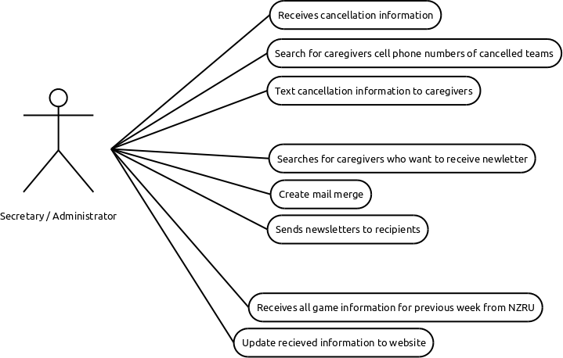

Tracking gear
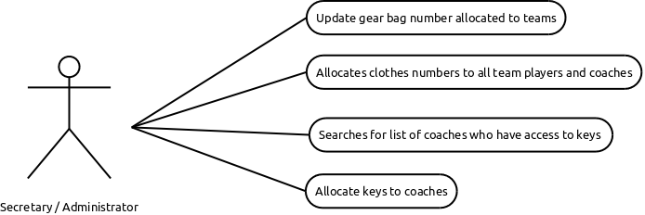

Shop Roster

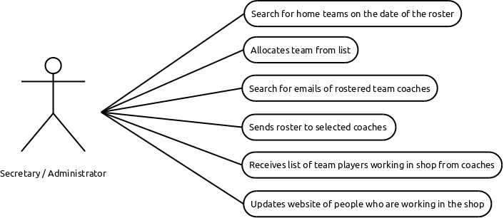Tracking Scores
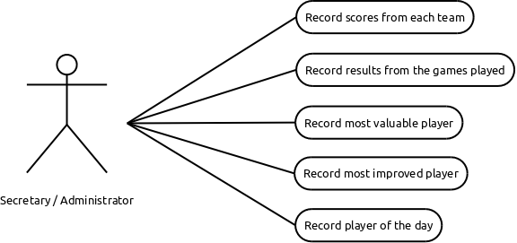

Data Model

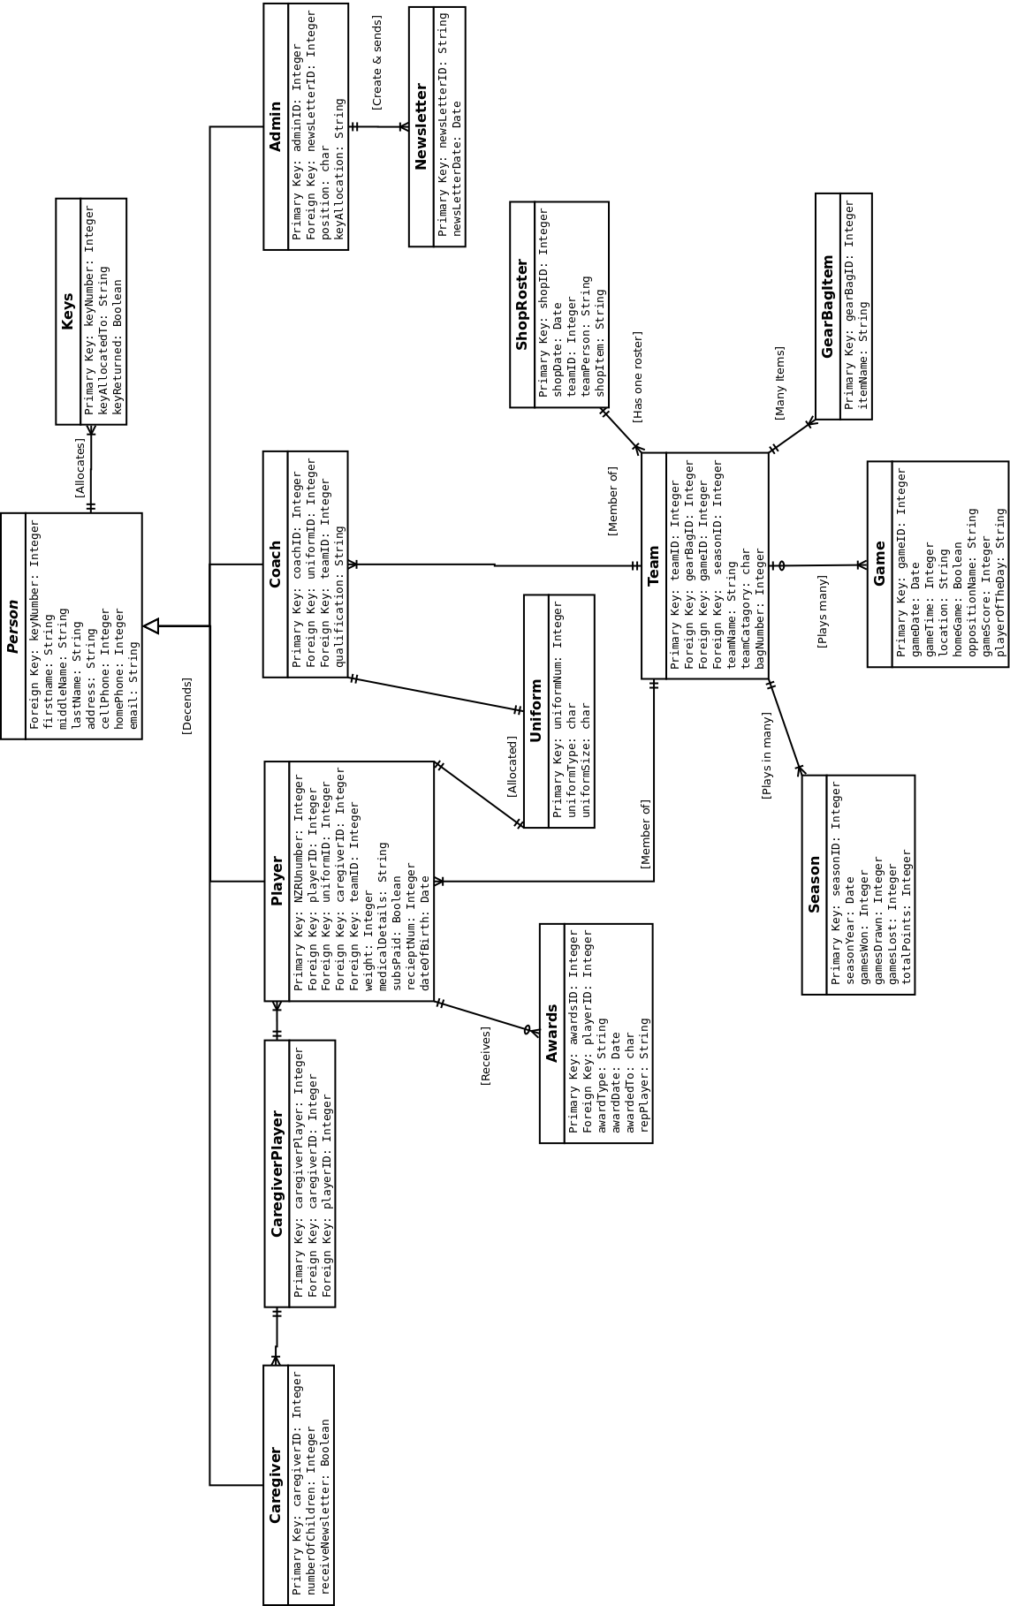

Data Dictionary
Table | Attribute | Data Type | Description
Person |  |  | Abstract Class
 | firstName  middleName  lastName  address  cellPhone  homePhoneNum  email | String  String  String  String  Integer  Integer  String | First Name  Middle Name  Last Name  Address  Cell number  Home number  Email address
Coach
 | coachID  uniformID  teamID  qualification | Integer  Integer  Integer  String | Primary key  Foreign key  Foreign key  Qualification of the coach
Player
 | NZRUNumber  playerID  uniformID  caregiverID  teamID  weight  medicalDetails  subsPaid  receiptNum  dateOfBirth | Integer  Integer  Integer  Integer  Integer  Integer  String  Boolean  Integer  Date | Primary key  Foreign key  Foreign key  Foreign key  Foreign key  Weight of player  Medical details of player  Has the subs been played  Receipt for players sub  Date of birth
Admin
 | adminID  newsLetterID  position  keyAllocated | Integer  Integer  char  String | Primary key  Foreign key  Staff position e.g. “Secretary”, “Treasurer”  Allocated person
Caregiver
 | caregiverID  numberOfChildren  receiveNewsLetter | Integer  Integer  Boolean | Primary key  Number of children that are players  Would like to receive a newsletter
Table | Attribute | Data Type | Description
CaregiverPlayer |  |  | Interface
 | caregiverPlayerID  caregiverID  playerID | Integer  Integer  Integer | Primary key  Foreign key  Foreign key
Season
 | seasonYear  gamesWon  gamesDrawn  gamesLost  totalPoints | Date  Integer  Integer  Integer  Integer | Primary key  How many games won  How many games drawn  How many games lost  Total points over the season
Game
 | gameID  gameDate  gameTime  location  homeGame  oppositionName  gameScore  playerOfTheDay | Integer  Date  Integer  String  Boolean  String  Integer  String | Primary key  Date of game  Time of game  Location of game  Is game HOME | AWAY  Opposition team name  Score of game  Who got player of the day
ShopRoster
 | shopID  shopDate  teamPerson  shopItem | Integer  Date  String  String | Primary key  Date shop open  Person in team allocated to shop  Items in the shop
GearBag
 | gearBagID  itemName | Integer  String | Primary key  Gear bag item name

Table | Attribute | Data Type | Description
Awards
 | awardsID  awardType  awardDate  awardedTo  repPlayer | Integer  String  char  String  String | Primary key  Award presented (e.g. MVP, MIP, REP)  Date award presented  Person who received award  Represented local or regional teams
Newsletter
 | newsletterID  newsLetterDate | Integer  Date | Primary key  Date of newsletter
Uniform
 | uniformNum  uniformType  uniformSize | Integer  Char  Char | Primary key  Clothes issued  Player size issued
Keys
 | keyNumber  keyAllocatedTo  keyReturned | Integer  String  Boolean | Primary key  Name of person key is allocated to  Record if returned at end of season

